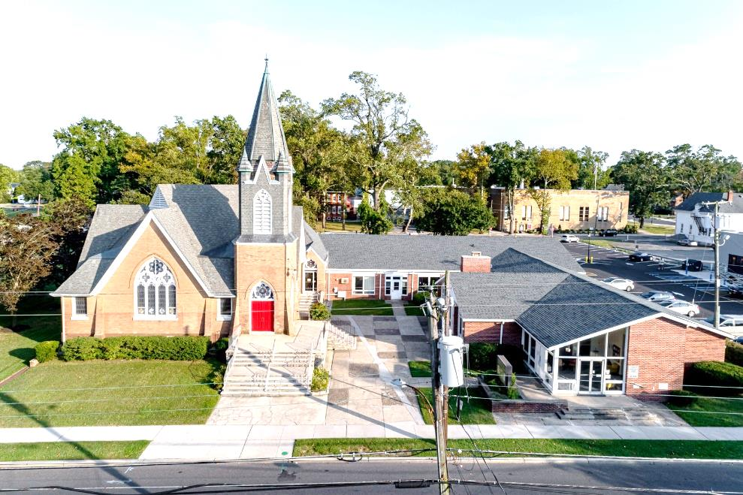

The Presbyterian Church at Hammonton
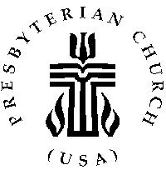

Our vision is to open our doors to all seeking a spiritual home of worship and to carry the light and love of Jesus Christ, our Savior, throughout the community.

MISSION STATEMENT
We are committed to Jesus Christ and the growing of his Church by glorifying God and by proclaiming the good news of the gospel through word and deed. We involve and reach out to our members and our community in Christ’s name through worship, Christian Education, and stewardship to support the mission of our church.

Note: Special thanks to Rev. Dr. Patty Epprecht for leading us in worship today.

Organist: Cindy Birnbaum
Sunday School Superintendent: Beth Burkett-Rice

2021 2022 2023
ELDERS
Frank Johnson Eric Copenhaver Robert Bauers
Robin Mishkovsky Marylee Kondrach Dorrine Esposito
Beth Burkett Rice Charles Muller Richard Walker

DEACONS
Kris Guldin Elsie Bakley Wendy Copenhaver
Carol Orsi Nancy Foster Ann DiMeo
Becky Villani Margaret Jones Rebecca Lindstrom

Clerk of Session: Beth Burkett-Rice

Church Office: 326 Bellevue Avenue, Hammonton, NJ
Office hours: Tuesday - Thursday 9:30 AM to 12:30 PM
Phone (609) 561-0168 ~ Fax (609) 561-6105
e-mail: office@hammontonpres.org
website: www.hammontonpres.org

THE CELEBRATION OF WORSHIP
JANUARY 30th, 2022
4TH SUNDAY AFTER EPIPHANY
VIRTUAL & LIVE SERVICE
11:00am
****************************************************
~ GATHERING IN GOD’S NAME ~
“Welcome to the Presbyterian Church at Hammonton, we are glad you are able to join us. As we gather for worship feel free to pray and meditate on God’s calling in your life. Be respectful of others around you who might be doing the same, prior and during the Prelude, keeping your voice and conversation soft and to a minimum.”
“When Christ calls a man, he bids him come and die.”
- Deitrich Bonhoeffer, “The Cost of Discipleship”

PRELUDE ~“Be Thou My Vision”-L. Larson
“How Can I Keep from Singing”-L. Smith
“Foundation”- B. Barrett

~ TIME FOR CENTERING STILLNESS AND SILENCE ~

WELCOME AND ANNOUNCEMENTS

*THE PEACE
Let the people greet one another by staying in their seats and saying: “Peace be with you!”

INTROIT
~ HUMBLY APPROACHING GOD ~

OPENING PRAYER

*CALL TO WORSHIP [Adaptation of Psalm 111 (CEB)]
Leader: Praise the Lord! With all your heart, praise the Lord!
And thank the Lord with every fiber of your being,
thank the Lord!
People: Do this right here where we are surrounded by this
congregation. The works of the Lord are magnificent
and are treasures to behold. God’s deeds are majestic and glorious. God’s righteousness stands forever.
Leader: The Lord is full of mercy and compassion and God
remembers God’s covenant forever.
People: God’s handiwork is honesty and justice; all God’s
rules are trustworthy and will always be forever and
ever.
Leader: God sent redemption for his people; God
commanded that God’s covenant lasts forever. Holy
and awesome is God’s name!
People: We gather this day, acknowledging God’s
awesomeness, and remembering that the fear of the
Lord is where wisdom beings. Sure knowledge is for
all who keep God’s laws.
All: God’s praise lasts forever!

*HYMN #466 “O for a Thousand Tongues to Sing”
CALL TO CONFESSION

PRAYER OF CONFESSION (unison)
Holy and merciful God, in your presence we confess our sinfulness, our shortcomings, and our offense against you. You alone know how often we have sinned in wandering from your ways, in wasting your gifts, in forgetting your love. Have mercy on us, O Lord, for we are ashamed and sorry for all we have done to displease you.
Forgive our sins and help us to live in your light and walk in your ways for the sake of Jesus Christ our Savior.
(silent confession)

ASSURANCE OF FORGIVENESS

*GLORIA PATRI

ANTHEM~ “Star-Led and Wonder-Bound”

CHILDREN’S MESSAGE

~ RECEIVING GOD’S WORD ~

PRAYER OF ILLUMINATION

SCRIPTURE READINGS

MESSAGE ~ “It’s About Time to Do What We are Called
to Do” - The Rev. Dr. Patricia Epprecht

~ RESPONDING TO THE WORD ~

*HYMN #447~ “Lead On, O King Eternal”

*SAYING WHAT WE BELIEVE
This is the good news which we have received,
in which we stand, and by which we are saved, if we hold fast:
that Christ died for our sins according to the scriptures,
that he was buried,
that he was raised on the third day,
and that he appeared
first to the women,
then to Peter, and to the Twelve,
and then to many faithful witnesses.
We believe that Jesus is the Christ,
the Son of the living God.
Jesus Christ is the first and the last,
the beginning and the end;
he is our Lord and our God.
AMEN

JOYS AND CONCERNS OF THE CHURCH

PASTORAL PRAYER & LORD’S PRAYER
Our Father, who art in heaven, hallowed be Thy name. Thy kingdom come, thy will be done, on earth as it is in heaven. Give us this day our daily bread; and forgive our debts as we forgive our debtors; and lead us not into temptation, but deliver us from evil. For Thine is the kingdom and the power and the glory, forever. Amen.

THE OFFERING OF OUR GIFTS AND OURSELVES

OFFERTORY ~ “Lead On O King Eternal”

OFFERTORY PRAYER

*DOXOLOGY (#592)
Praise God, from whom all blessings flow; Praise Him, all creatures here below; Praise Him above, ye heavenly host; Praise Father, Son, and Holy Ghost. Amen.

~ GOING IN GOD’S NAME ~

*HYMN #416~ “Christ Is Made the Sure Foundation ”
(Vs. 1 & 4)

*THE CHARGE AND BENEDICTION

POSTLUDE~ “Praise and Glory” – R. Schram

OUR WORSHIP HAS ENDED, LET OUR SERVICE BEGIN

*Signifies stand if comfortable.

______________________________________________

CHURCH EVENTS
>>>THIS WEEK:
Monday-01/31:
9:00 AM Clothing Closet
-12:00 PM

Tuesday-02/01:
9:00 AM Clothing Closet
-12:00 PM

Wednesday-02/02:
9:00 AM Clothing Closet
-12:00 PM

______________________________________________
>>UPCOMING:
Monday-02/07:
9:00 AM Clothing Closet
-12:00 PM

Tuesday-02/08:
9:00 AM Clothing Closet
-12:00 PM

Wednesday-02/09:
9:00 AM Clothing Closet
-12:00 PM

______________________________________________
BIRTHDAYS:
Feb. 2 William Roeschen
Feb. 4 Pastor Howard Clarke Smith
______________________________________________
ANNIVERSARIES:

Feb. 4 Eric & Wendy Copenhaver

SERVING YOU TODAY:
Liturgist: Rick & Millie Walker

Ushers: Richard Walker, Captain
Richard Gibson
Ruth Gibson
Bob Rebek
Millie Walker

**Children’s Church Rebecca Villani
Next week: Dorrine Esposito

